Shear

Definition
# Source: AI Source: Provided by: [Data Path: Persons Table -> ID Column: 1, Name_En Column: Motasem Essam] -> From: [ChatGPT] on [7/25/2026]
Shear is a geometric transformation that slants or skews a figure by shifting its points in one direction by an amount that depends on their position.
Unlike translation, rotation, reflection, and dilation, a shear generally changes the angles and shape of a figure while keeping lines parallel to the direction of the shear parallel.
A shear can transform:
- A rectangle into a parallelogram.
- A square into a slanted parallelogram.
- A circle into an ellipse-like shape.
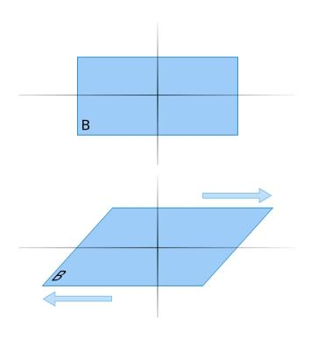
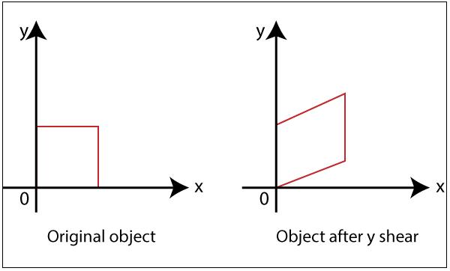
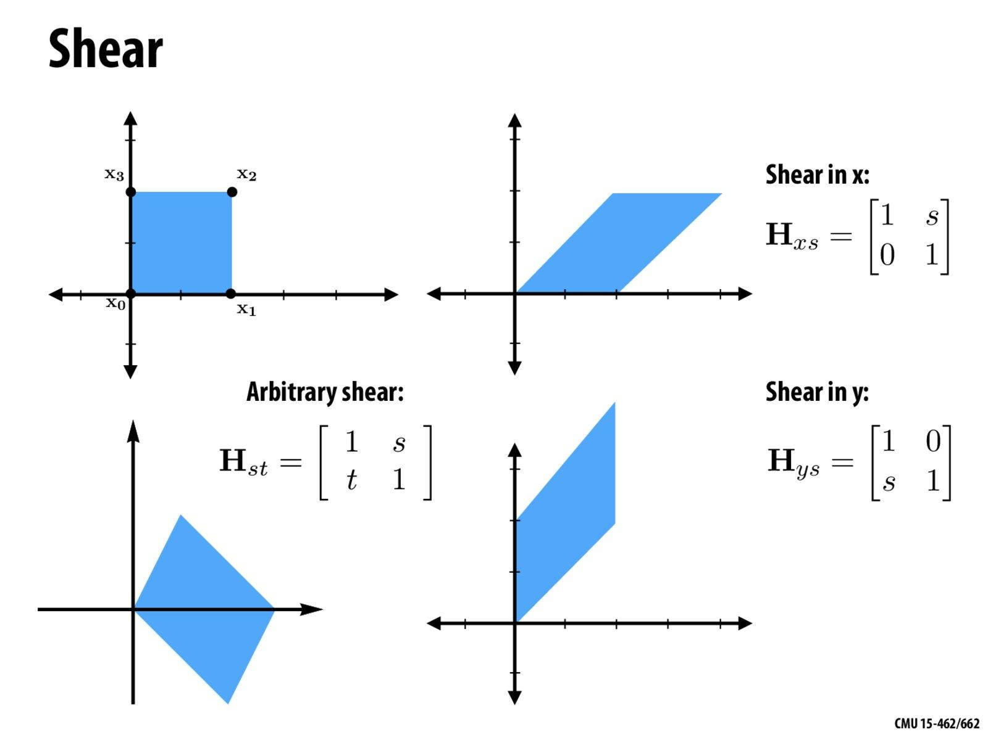
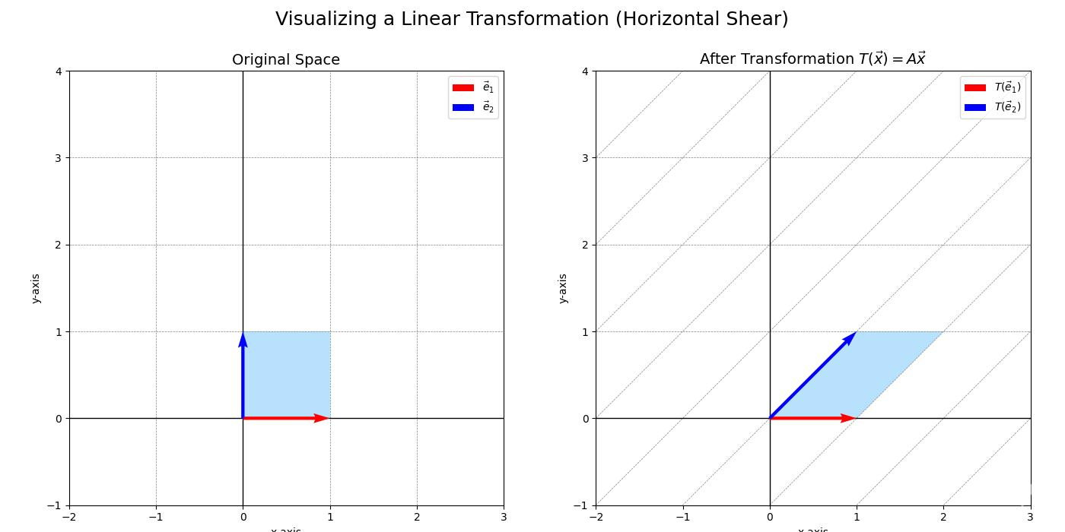
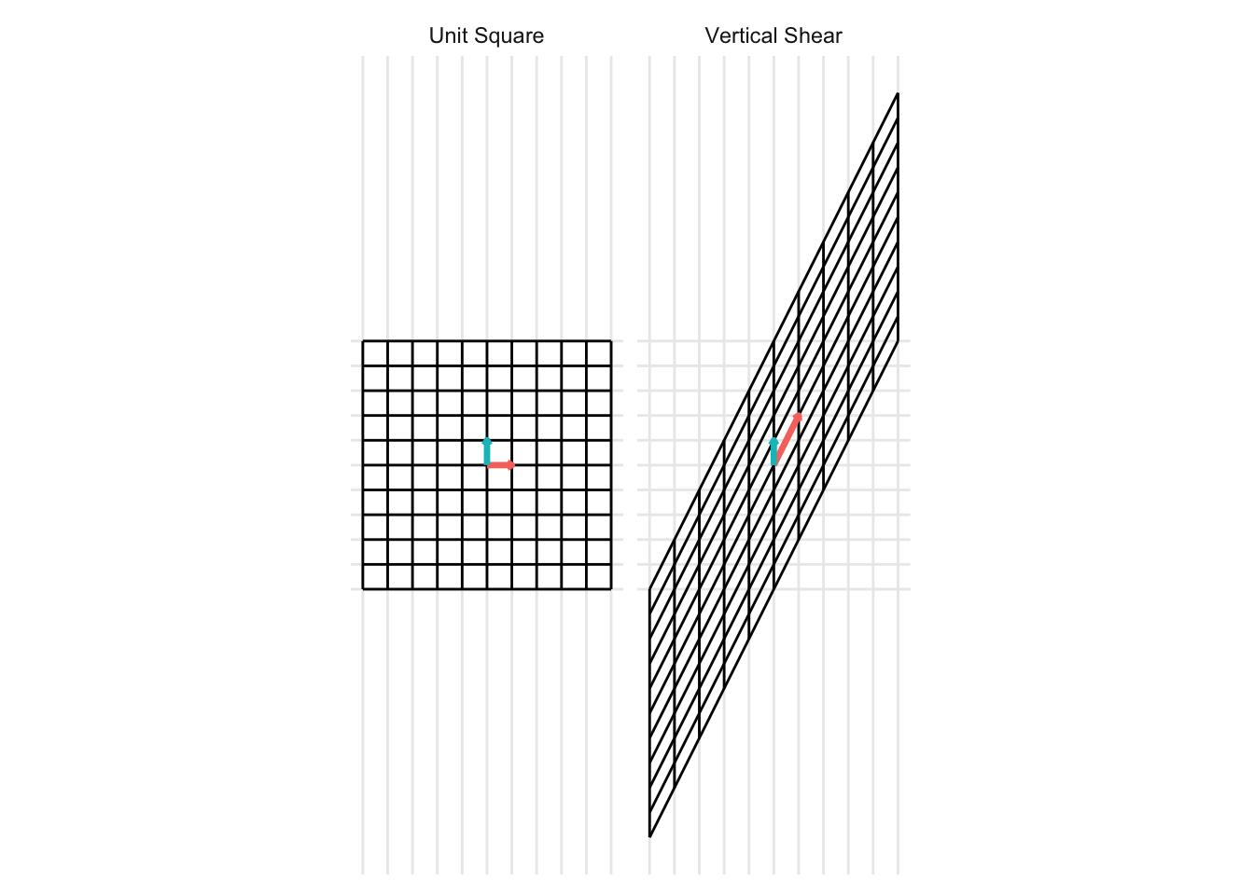
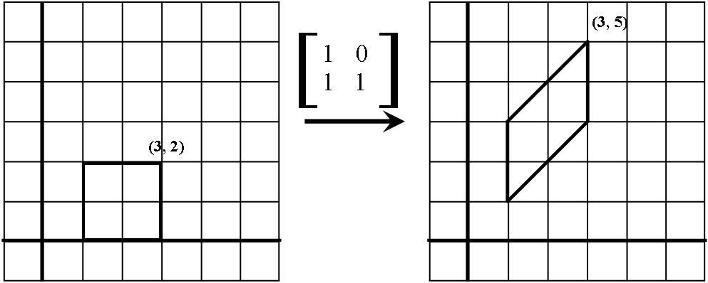

Purpose
# Source: AI Source: Provided by: [Data Path: Persons Table -> ID Column: 1, Name_En Column: Motasem Essam] -> From: [ChatGPT] on [7/25/2026]
Shear transformations are used to:
- Slant geometric figures.
- Transform rectangles into parallelograms.
- Study non-rigid transformations.
- Modify coordinates.
- Create graphical effects.
- Transform images and shapes.
- Support computer graphics.
- Support CAD and engineering design.
- Model deformation and distortion.

Fundamental Idea
# Source: AI Source: Provided by: [Data Path: Persons Table -> ID Column: 1, Name_En Column: Motasem Essam] -> From: [ChatGPT] on [7/25/2026]
A shear moves points parallel to a fixed direction.
The amount of movement depends on the point's position.
For example, in a horizontal shear, points move horizontally while their $y$-coordinates remain unchanged.
$$\boxed{\left(x, y\right)→\left(x +ky,y\right)}$$
where:
- $k$ = shear factor
- $x$ = original horizontal coordinate
- $y$ = original vertical coordinate
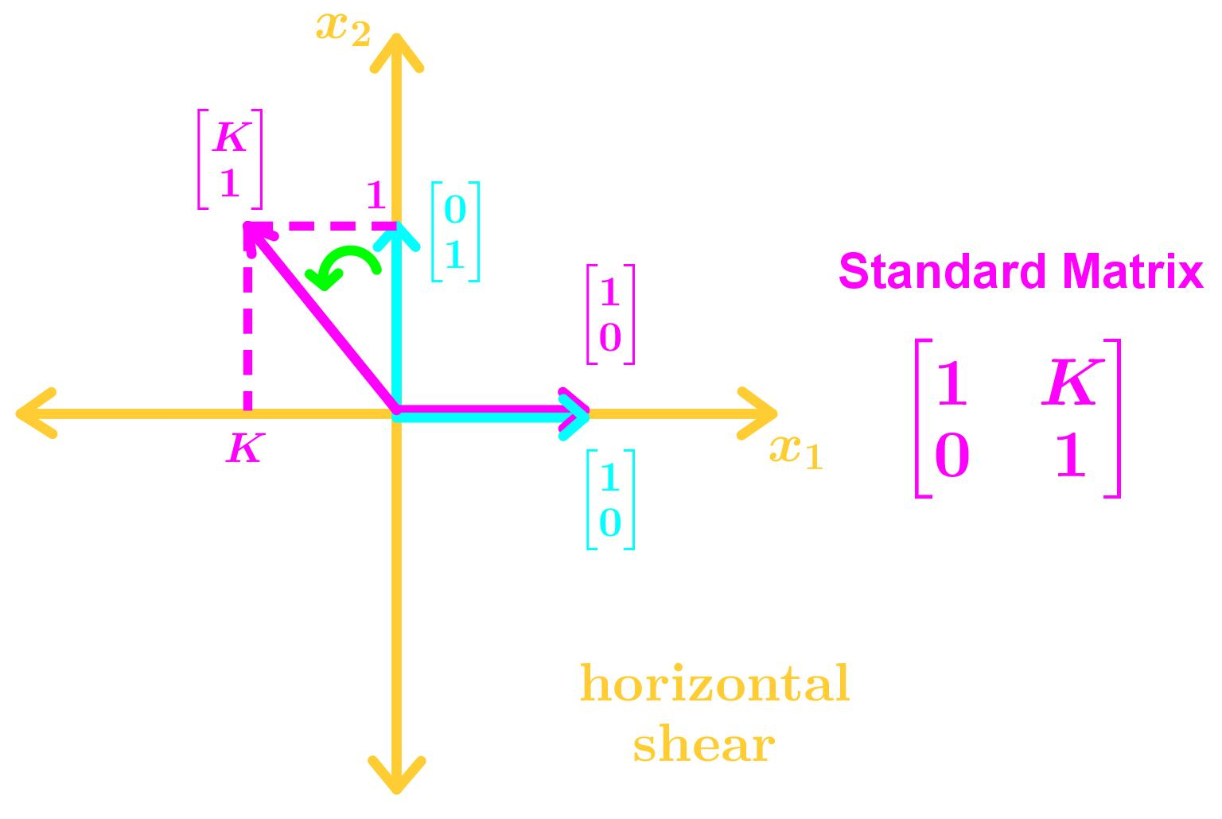
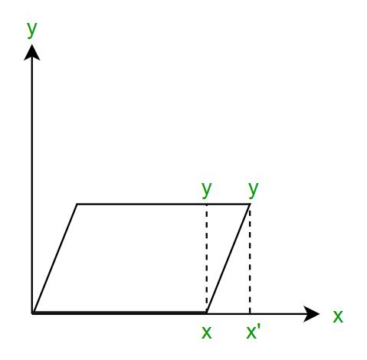

Shear Factor
# Source: AI Source: Provided by: [Data Path: Persons Table -> ID Column: 1, Name_En Column: Motasem Essam] -> From: [ChatGPT] on [7/25/2026]
The amount of slanting is controlled by the shear factor.
It is usually represented by:
$$\boxed{k}$$
A larger absolute value of $k$ produces a stronger shear.
For example:
$$k=0.5$$
produces a moderate shear, while:
$$k=2$$
produces a stronger shear.

Horizontal Shear
# Source: AI Source: Provided by: [Data Path: Persons Table -> ID Column: 1, Name_En Column: Motasem Essam] -> From: [ChatGPT] on [7/25/2026]
A horizontal shear moves points horizontally.
The $y$-coordinate remains unchanged.
The coordinate rule is:
$$\boxed{\left(x, y\right)→\left(x +ky,y\right)}$$
where $k$ is the horizontal shear factor.
Example
Suppose:
$$A=\left(2 , 3\right)$$
and:
$$k=2$$
Then:
$$x^{'}=x+ky \\ x^{'}=2+2\left(3\right) \\ x^{'}=8$$
and:
$$y^{'}=3$$
Therefore:
$$\boxed{A^{'}=\left(8 , 3\right)}$$

Negative Horizontal Shear
# Source: AI Source: Provided by: [Data Path: Persons Table -> ID Column: 1, Name_En Column: Motasem Essam] -> From: [ChatGPT] on [7/25/2026]
If the shear factor is negative:
$$k<0$$
the point moves in the opposite horizontal direction.
For example:
$$k=-1$$
gives:
$$\boxed{\left(x, y\right)→\left(x -y,y\right)}$$
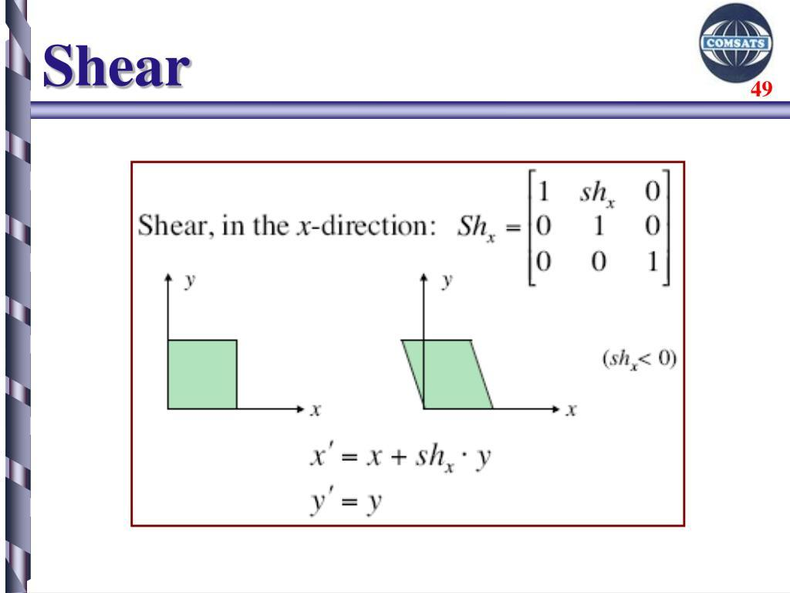
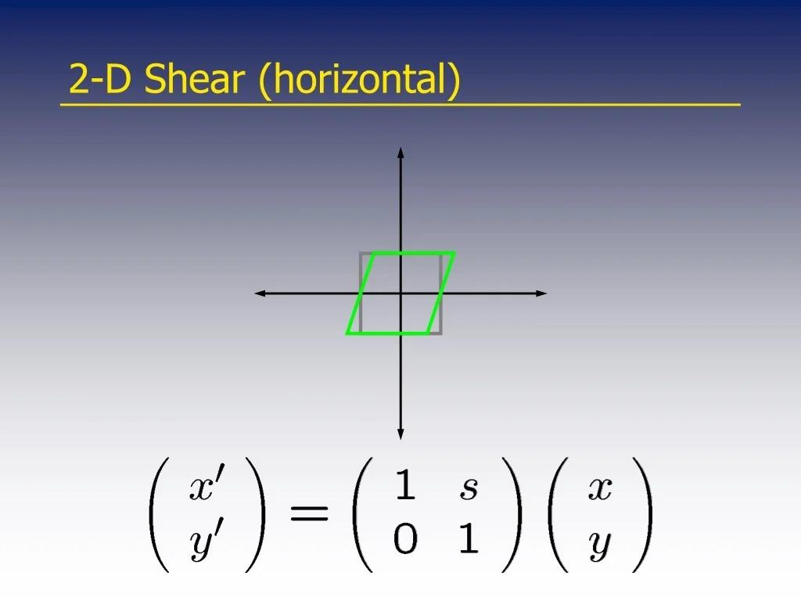

Vertical Shear
# Source: AI Source: Provided by: [Data Path: Persons Table -> ID Column: 1, Name_En Column: Motasem Essam] -> From: [ChatGPT] on [7/25/2026]
A vertical shear moves points vertically.
The $x$-coordinate remains unchanged.
The coordinate rule is:
$$\boxed{\left(x , y\right)→\left(x , y+kx\right)}$$
where $k$is the vertical shear factor.
Example
Suppose:
$$A=\left(2 , 3\right)$$
and:
$$k=2$$
Then:
$$y^{'}=y+kx \\ y^{'}=3+2\left(2\right) \\ y^{'}=7$$
Therefore:
$$\boxed{A^{'}=\left(2 , 7\right)}$$
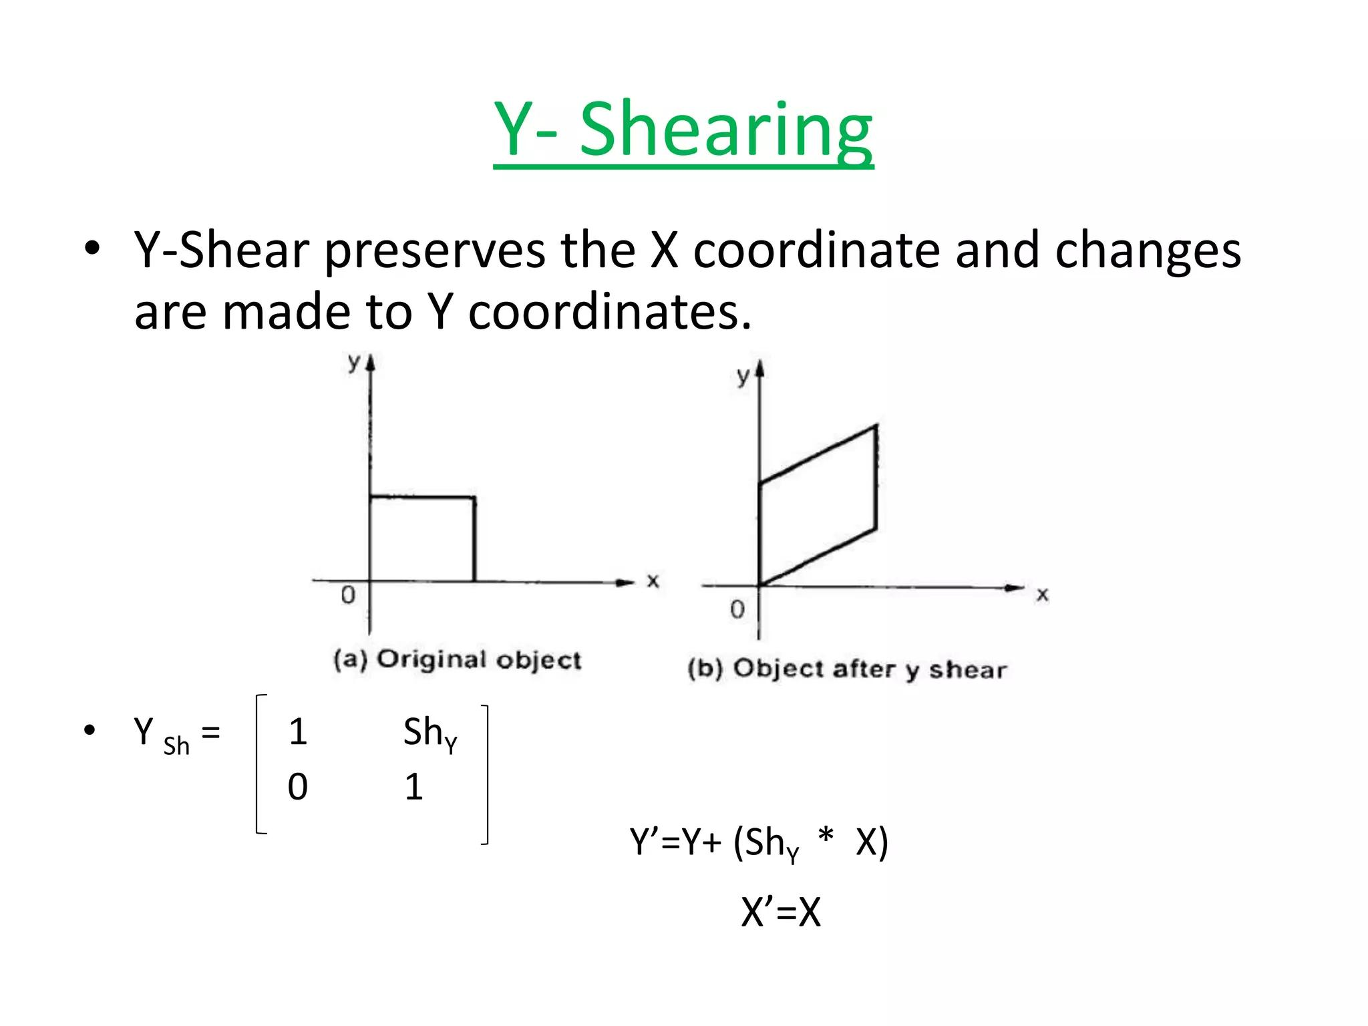
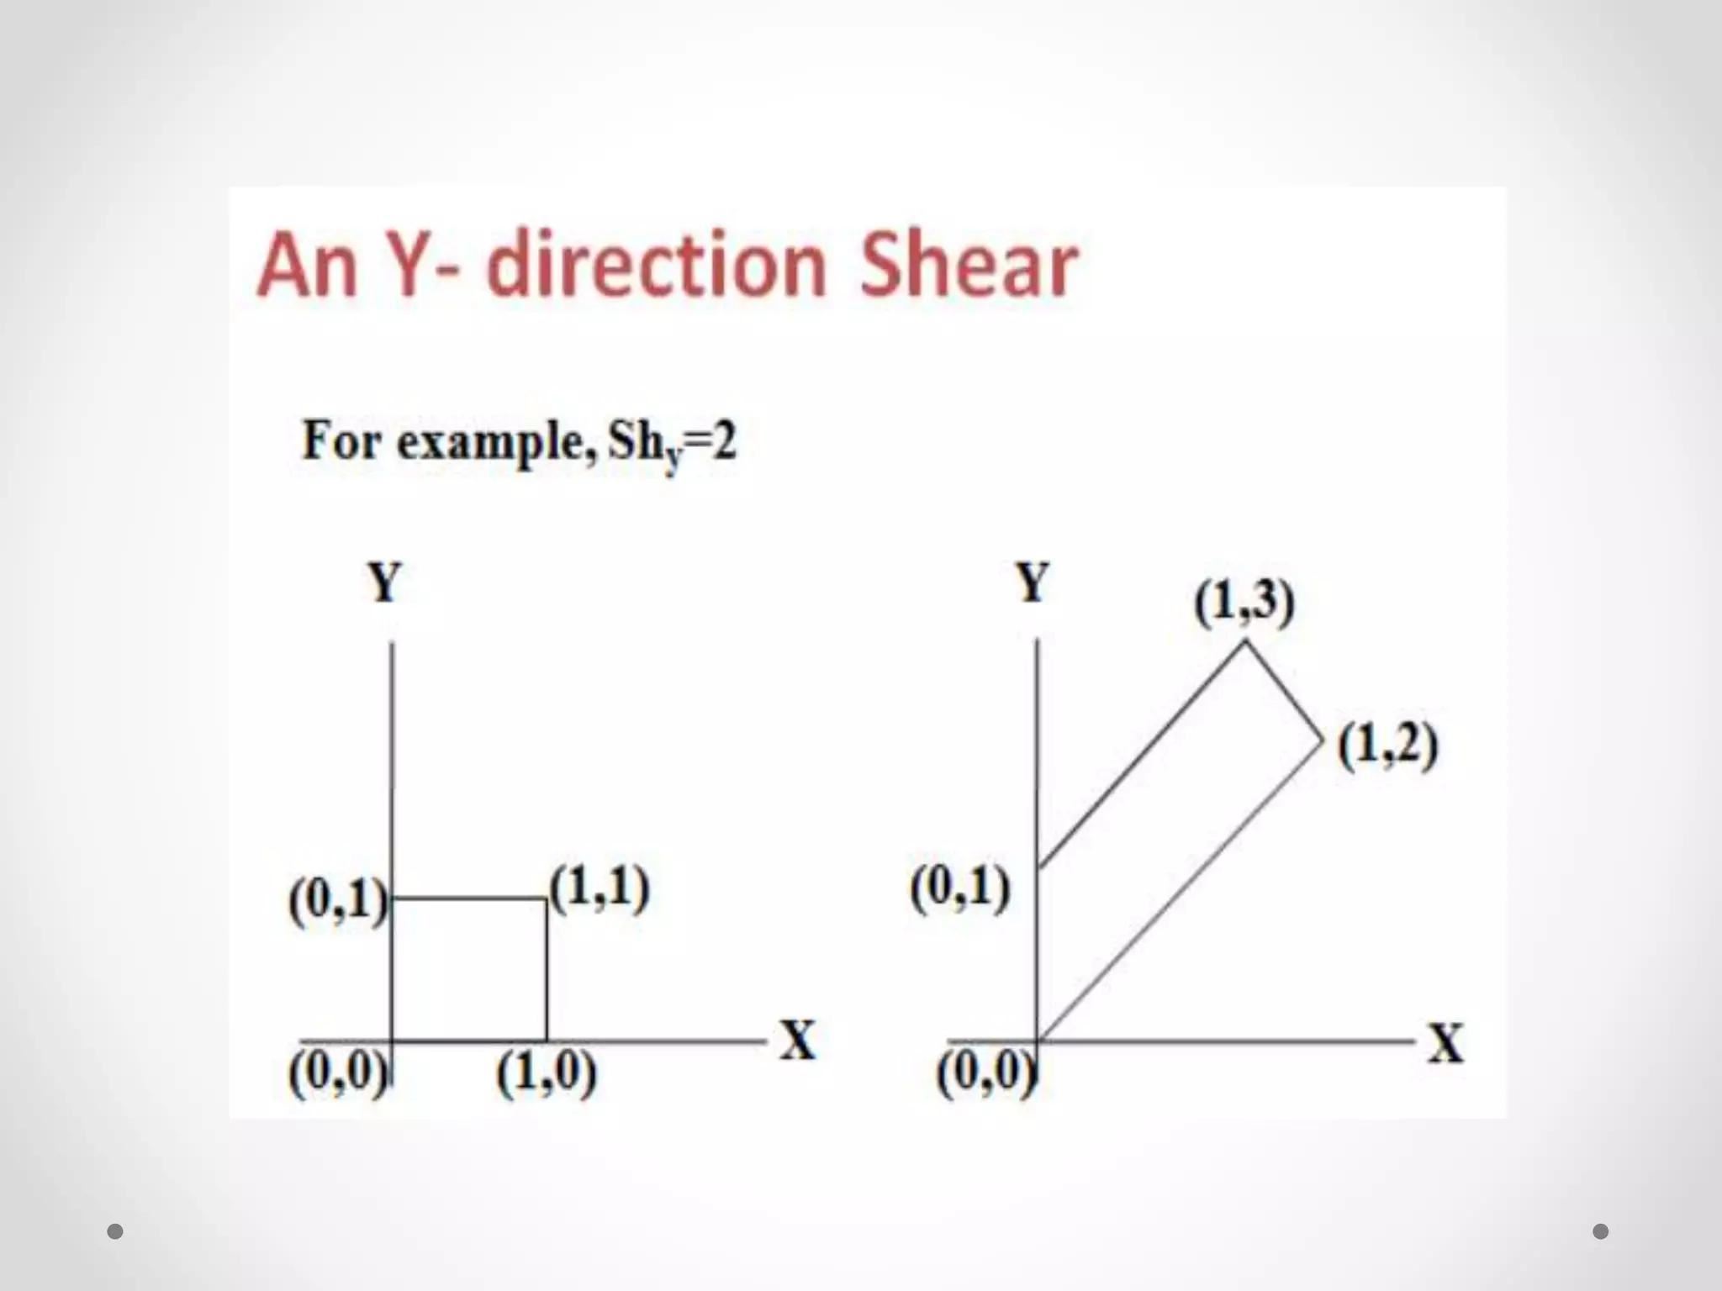

Negative Vertical Shear
# Source: AI Source: Provided by: [Data Path: Persons Table -> ID Column: 1, Name_En Column: Motasem Essam] -> From: [ChatGPT] on [7/25/2026]
If:
$$k<0$$
the point moves in the opposite vertical direction.
For example:
$$k=-1$$
gives:
$$\boxed{\left(x , y\right)→\left(x , y-x\right)}$$

Horizontal vs Vertical Shear
# Source: AI Source: Provided by: [Data Path: Persons Table -> ID Column: 1, Name_En Column: Motasem Essam] -> From: [ChatGPT] on [7/25/2026]
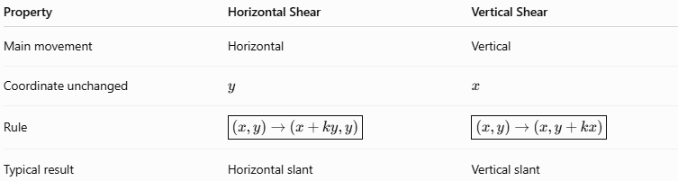
Property | Horizontal Shear | Vertical Shear
Main movement | Horizontal | Vertical
Coordinate unchanged | $$y$$ | $$x$$
Rule | $$\boxed{\left(x, y\right)→\left(x +ky,y\right)}$$ | $$\boxed{\left(x , y\right)→\left(x , y+kx\right)}$$
Typical result | Horizontal slant | Vertical slant
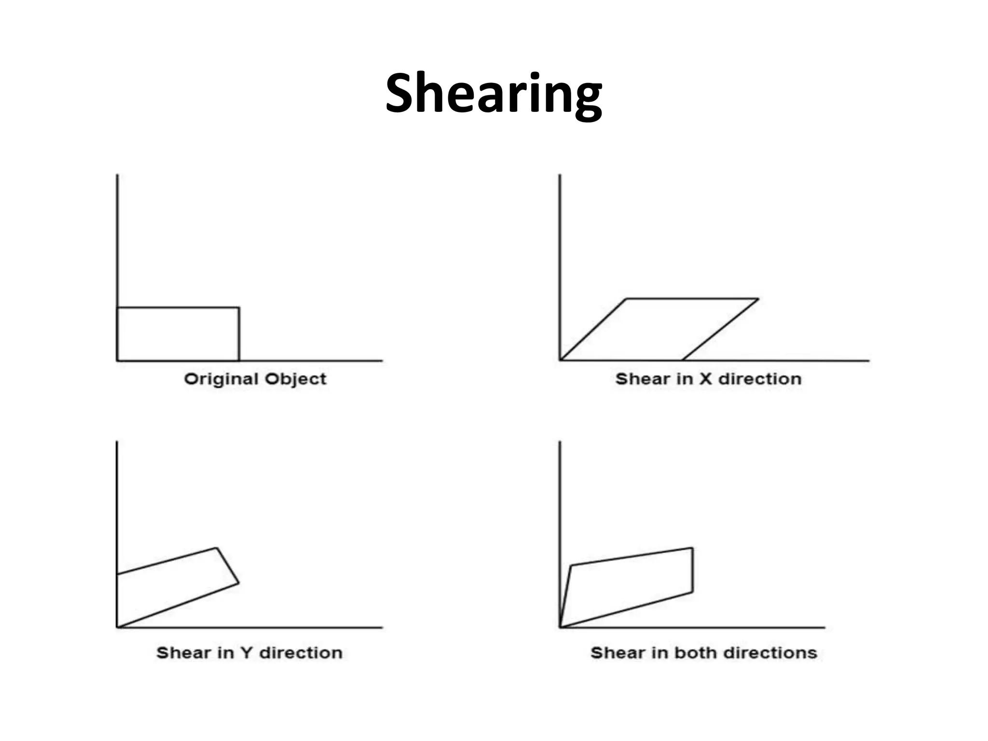

Shearing a Rectangle
# Source: AI Source: Provided by: [Data Path: Persons Table -> ID Column: 1, Name_En Column: Motasem Essam] -> From: [ChatGPT] on [7/25/2026]
Consider a rectangle.
After a horizontal shear, the top and bottom remain horizontal, but the vertical sides become slanted.
The rectangle becomes a parallelogram.
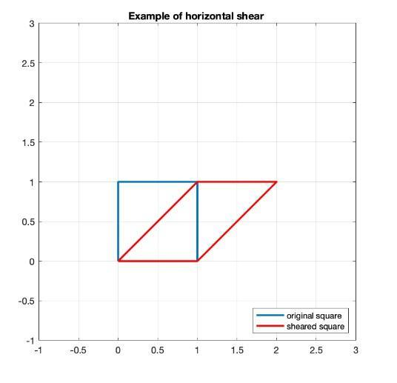
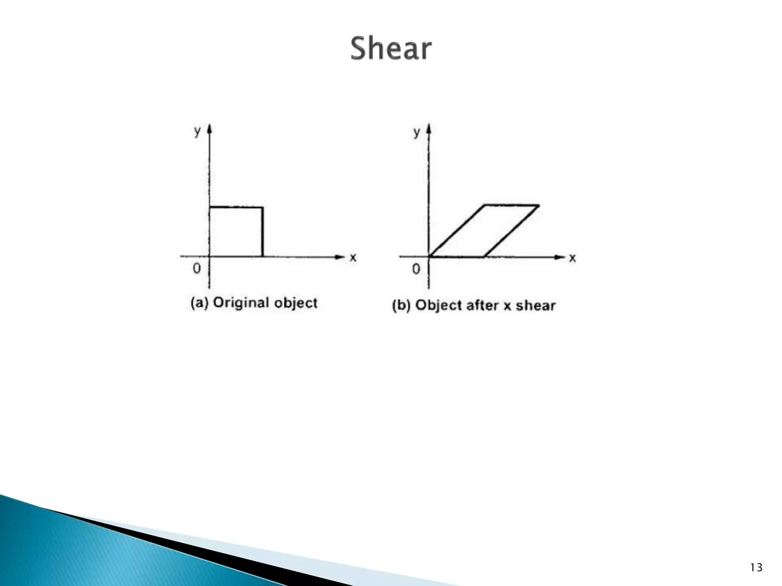

Example of Horizontal Shear
# Source: AI Source: Provided by: [Data Path: Persons Table -> ID Column: 1, Name_En Column: Motasem Essam] -> From: [ChatGPT] on [7/25/2026]
Consider the rectangle with vertices:
$$A=\left(0 , 0\right) \\ B=\left(4 , 0\right) \\ C=\left(4 , 3\right) \\ D=\left(0 , 3\right)$$
Apply a horizontal shear with:
$$k=1$$
Using:
$$\left(x, y\right)→\left(x +y,y\right)$$
we obtain:
$$A^{'}=\left(0 , 0\right) \\ B^{'}=\left(4 , 0\right) \\ C^{'}=\left(7 , 3\right) \\ D^{'}=\left(3 , 3\right)$$
The rectangle becomes a parallelogram.
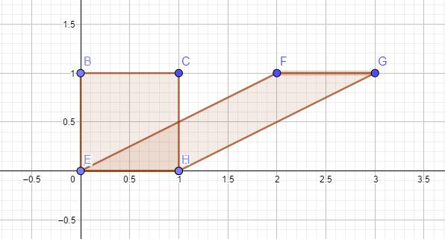
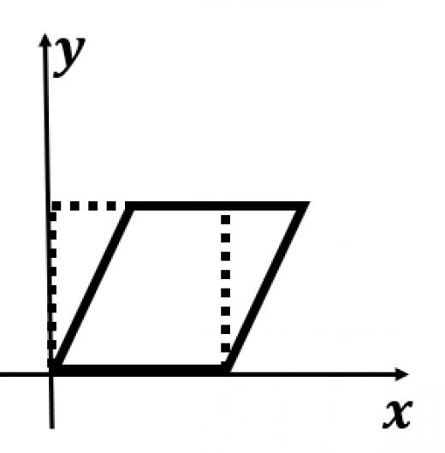

Shearing a Square
# Source: AI Source: Provided by: [Data Path: Persons Table -> ID Column: 1, Name_En Column: Motasem Essam] -> From: [ChatGPT] on [7/25/2026]
A square can also be transformed by a shear.
For example:
$$\left(0 , 0\right), \left(4 , 0\right), \left(4 , 4\right), \left(0 , 4\right)$$
After a horizontal shear:
$$\left(x, y\right)→\left(x +y,y\right)$$
the upper vertices move horizontally while the lower vertices remain fixed.
The resulting shape is a parallelogram rather than a square.

Shearing a Triangle
# Source: AI Source: Provided by: [Data Path: Persons Table -> ID Column: 1, Name_En Column: Motasem Essam] -> From: [ChatGPT] on [7/25/2026]
Shear can also transform triangles.
Suppose:
$$A=\left(0 , 0\right) \\ B=\left(4 , 0\right) \\ C=\left(2 , 3\right)$$
Apply horizontal shear:
$$\left(x, y\right)→\left(x +y,y\right)$$
Then:
$$A^{'}=\left(0 , 0\right) \\ B^{'}=\left(4 , 0\right) \\ C^{'}=\left(5 , 3\right)$$
The triangle is slanted, but it remains a triangle.
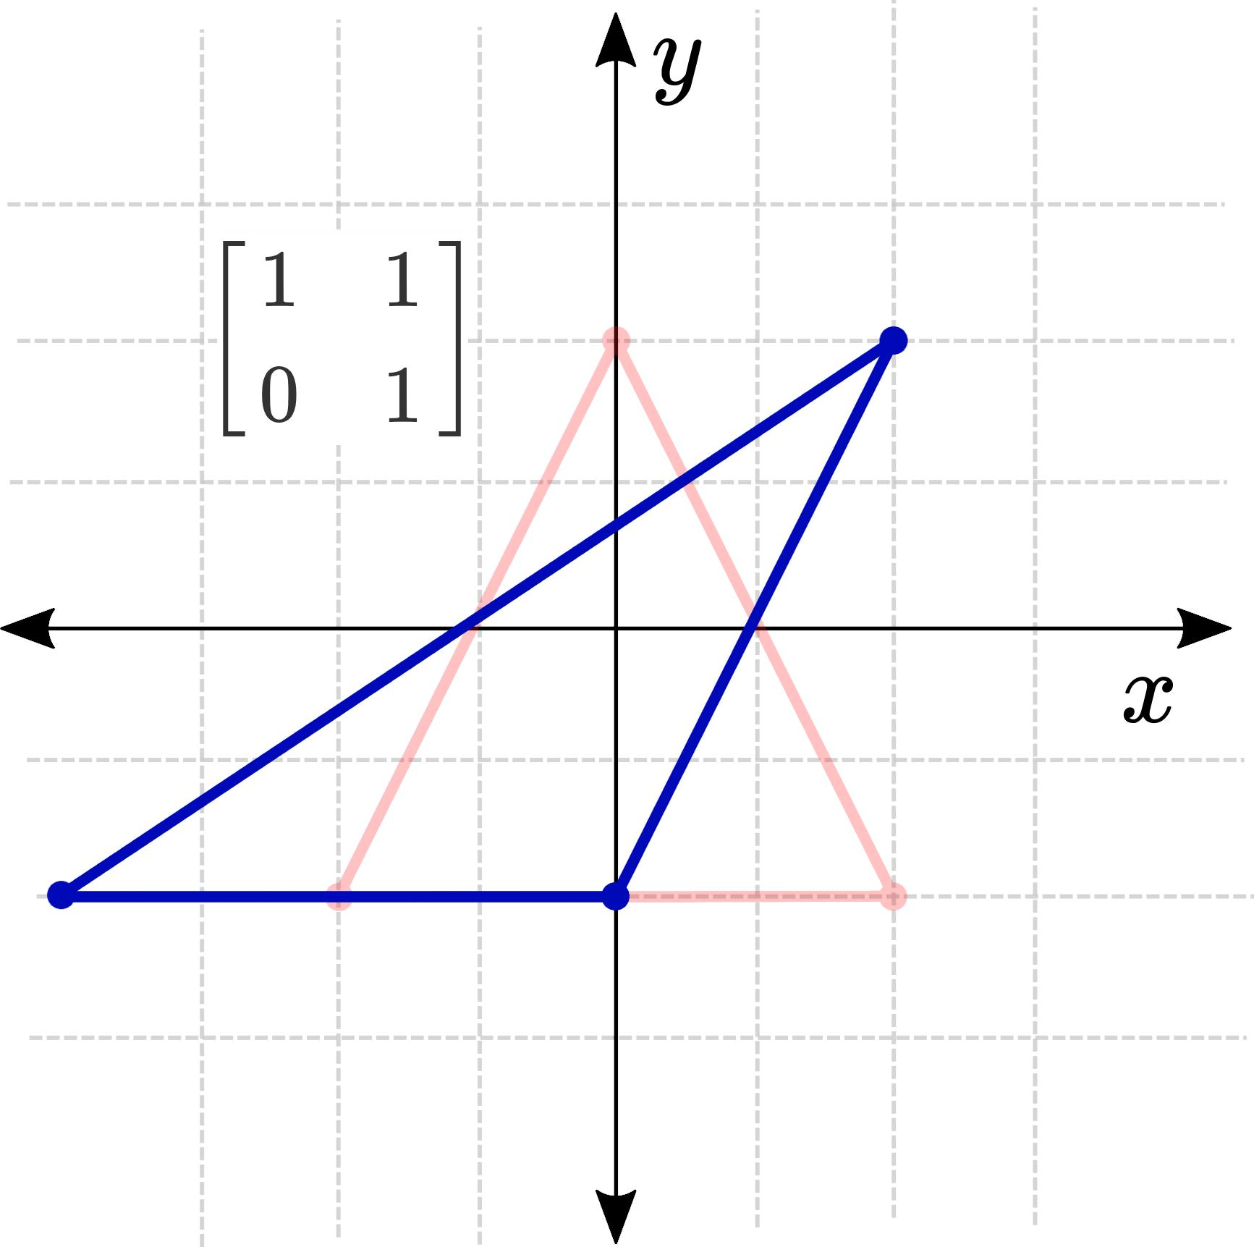
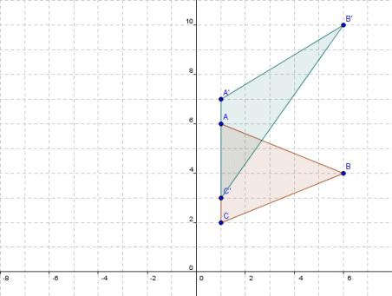
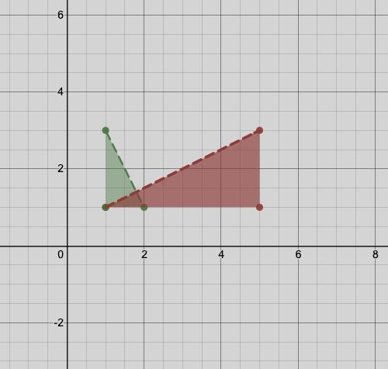

Shear Changes Angles
# Source: AI Source: Provided by: [Data Path: Persons Table -> ID Column: 1, Name_En Column: Motasem Essam] -> From: [ChatGPT] on [7/25/2026]
One of the most important properties of shear is that it generally changes angle measures.
For example, a right angle may become an acute or obtuse angle.
Therefore:
$$\boxed{\text{Angles are generally not preserved}}$$
This distinguishes shear from rigid transformations.

Shear Changes Shape
# Source: AI Source: Provided by: [Data Path: Persons Table -> ID Column: 1, Name_En Column: Motasem Essam] -> From: [ChatGPT] on [7/25/2026]
A shear generally changes the shape of a figure.
For example:
$$\boxed{\text{Rectangle}→\text{Parallelogram}}$$
Therefore, the original and transformed figures are generally not congruent.

Shear Preserves Parallelism
# Source: AI Source: Provided by: [Data Path: Persons Table -> ID Column: 1, Name_En Column: Motasem Essam] -> From: [ChatGPT] on [7/25/2026]
One important property of shear is that parallel lines remain parallel.
If two lines are parallel before the transformation, their corresponding image lines remain parallel.
$$\boxed{l_{1}∥l_{2}⇒l_{1}^{'}∥l_{2}^{'}}$$
This is called preservation of parallelism.

Shear Preserves Collinearity
# Source: AI Source: Provided by: [Data Path: Persons Table -> ID Column: 1, Name_En Column: Motasem Essam] -> From: [ChatGPT] on [7/25/2026]
Points that lie on the same straight line remain on the same straight line after a shear.
If:
$$A,B,C$$
are collinear, then:
$$\boxed{A^{'},B^{'},C^{'}\text{ are collinear}}$$

Shear Preserves Area
# Source: AI Source: Provided by: [Data Path: Persons Table -> ID Column: 1, Name_En Column: Motasem Essam] -> From: [ChatGPT] on [7/25/2026]
For a standard horizontal or vertical shear, the area of a figure remains unchanged.
$$\boxed{A^{'}=A}$$
For example, a rectangle with area:
$$A=12$$
will still have:
$$\boxed{A^{'}=12}$$
after a standard shear.
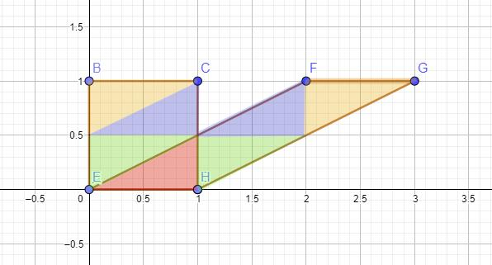
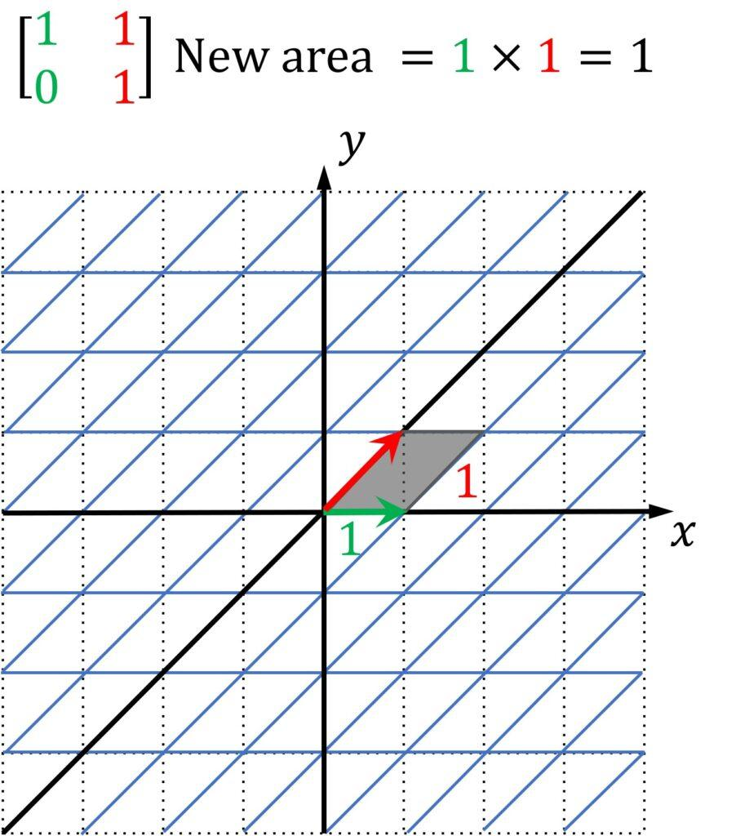

Shear Changes Perimeter
# Source: AI Source: Provided by: [Data Path: Persons Table -> ID Column: 1, Name_En Column: Motasem Essam] -> From: [ChatGPT] on [7/25/2026]
Although standard shear preserves area, it generally changes the lengths of some sides.
Therefore, the perimeter generally changes:
$$\boxed{P^{'}≠P}$$
For example, the vertical sides of a rectangle become slanted and therefore longer.

Shear Changes Distances
# Source: AI Source: Provided by: [Data Path: Persons Table -> ID Column: 1, Name_En Column: Motasem Essam] -> From: [ChatGPT] on [7/25/2026]
Shear does not generally preserve distances.
For example:
$$AB≠A^{'}B^{'}$$
for many pairs of corresponding points.
Therefore, shear is not a rigid transformation.

Shear Preserves One Direction
# Source: AI Source: Provided by: [Data Path: Persons Table -> ID Column: 1, Name_En Column: Motasem Essam] -> From: [ChatGPT] on [7/25/2026]
In a horizontal shear:
$$\left(x, y\right)→\left(x +ky,y\right)$$
horizontal lines remain horizontal.
In a vertical shear:
$$\left(x , y\right)→\left(x , y+kx\right)$$
vertical lines remain vertical.
Thus, one family of parallel lines remains unchanged in direction.

Matrix Representation
# Source: AI Source: Provided by: [Data Path: Persons Table -> ID Column: 1, Name_En Column: Motasem Essam] -> From: [ChatGPT] on [7/25/2026]
Shear can be represented using a transformation matrix.
Horizontal Shear
$$\boxed{\left(\begin{matrix}x^{'} \\ y^{'}\end{matrix}\right)=\left(\begin{matrix}1 & k \\ 0 & 1\end{matrix}\right)\left(\begin{matrix}x \\ y\end{matrix}\right)}$$
Therefore:
$$\boxed{x^{'}=x+ky} \\ \boxed{y^{'}=y}$$
Vertical Shear
$$\boxed{\left(\begin{matrix}x^{'} \\ y^{'}\end{matrix}\right)=\left(\begin{matrix}1 & 0 \\ k & 1\end{matrix}\right)\left(\begin{matrix}x \\ y\end{matrix}\right)}$$
Therefore:
$$\boxed{x^{'}=x} \\ \boxed{y^{'}=y+kx}$$

Determinant and Area
# Source: AI Source: Provided by: [Data Path: Persons Table -> ID Column: 1, Name_En Column: Motasem Essam] -> From: [ChatGPT] on [7/25/2026]
The horizontal shear matrix is:
$$\left(\begin{matrix}1 & k \\ 0 & 1\end{matrix}\right)$$
Its determinant is:
$$\det\left(\begin{matrix}1 & k \\ 0 & 1\end{matrix}\right)=1$$
Therefore, the area scale factor is:
$$\boxed{1}$$
So the area is preserved.
The same is true for the standard vertical shear matrix.

Shear vs Dilation
# Source: AI Source: Provided by: [Data Path: Persons Table -> ID Column: 1, Name_En Column: Motasem Essam] -> From: [ChatGPT] on [7/25/2026]
Shear and dilation are different transformations.
Dilation
Changes size while preserving shape and angles.
$$\boxed{A^{'}=k^{2}A}$$
Shear
Changes shape and generally changes angles while preserving area for standard shear.
$$\boxed{A^{'}=A}$$
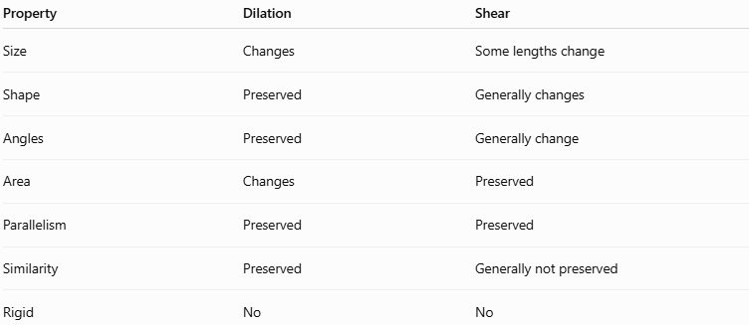
Property | Dilation | Shear
Size | Changes | Some lengths change
Shape | Preserved | Generally changes
Angles | Preserved | Generally change
Area | Changes | Preserved
Parallelism | Preserved | Preserved
Similarity | Preserved | Generally not preserved
Rigid | No | No

Shear vs Translation
# Source: AI Source: Provided by: [Data Path: Persons Table -> ID Column: 1, Name_En Column: Motasem Essam] -> From: [ChatGPT] on [7/25/2026]
Translation
Moves every point by the same distance and direction.
$$\boxed{\left(x, y\right)→\left(x +a,y+b\right)}$$
Shear
Moves different points by different amounts depending on their coordinates.
Horizontal shear:
$$\boxed{\left(x, y\right)→\left(x +ky,y\right)}$$
Therefore, translation preserves the shape, while shear generally changes it.

Shear vs Rotation
# Source: AI Source: Provided by: [Data Path: Persons Table -> ID Column: 1, Name_En Column: Motasem Essam] -> From: [ChatGPT] on [7/25/2026]
A rotation turns the entire figure around a fixed point.
A shear slants the figure without simply rotating it.
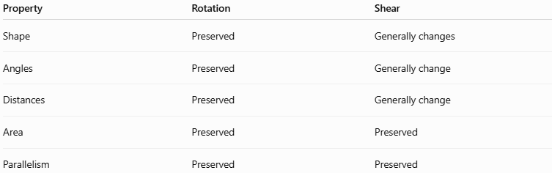
Property | Rotation | Shear
Shape | Preserved | Generally changes
Angles | Preserved | Generally change
Distances | Preserved | Generally change
Area | Preserved | Preserved
Parallelism | Preserved | Preserved

Shear vs Reflection
# Source: AI Source: Provided by: [Data Path: Persons Table -> ID Column: 1, Name_En Column: Motasem Essam] -> From: [ChatGPT] on [7/25/2026]
Reflection creates a mirror image.
Shear slants or skews the figure.
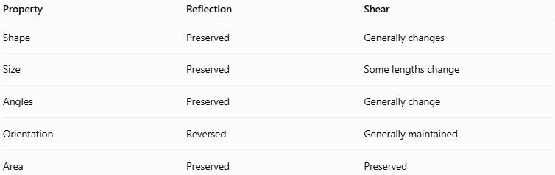
Property | Reflection | Shear
Shape | Preserved | Generally changes
Size | Preserved | Some lengths change
Angles | Preserved | Generally change
Orientation | Reversed | Generally maintained
Area | Preserved | Preserved

Shear and Congruence
# Source: AI Source: Provided by: [Data Path: Persons Table -> ID Column: 1, Name_En Column: Motasem Essam] -> From: [ChatGPT] on [7/25/2026]
A shear generally does not preserve distances.
Therefore, the original and sheared figures are generally not congruent.
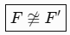
$$\boxed{F≇F^{'}}$$
unless the shear factor is:
$$\boxed{k=0}$$
When:
$$k=0$$
the transformation becomes the identity:
$$\left(x , y\right)→\left(x , y\right)$$

Shear and Similarity
# Source: AI Source: Provided by: [Data Path: Persons Table -> ID Column: 1, Name_En Column: Motasem Essam] -> From: [ChatGPT] on [7/25/2026]
A general nonzero shear does not preserve angle measures or side-length ratios.
Therefore, the original and sheared figures are generally not similar.
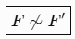
$$\boxed{F≁F^{'}}$$
This distinguishes shear from dilation.

Shear in Computer Graphics
# Source: AI Source: Provided by: [Data Path: Persons Table -> ID Column: 1, Name_En Column: Motasem Essam] -> From: [ChatGPT] on [7/25/2026]
Shearing is used to:
- Slant images.
- Create italic text effects.
- Produce perspective-like effects.
- Distort sprites.
- Transform graphical objects.
- Create animation effects.
- Modify 2D shapes.
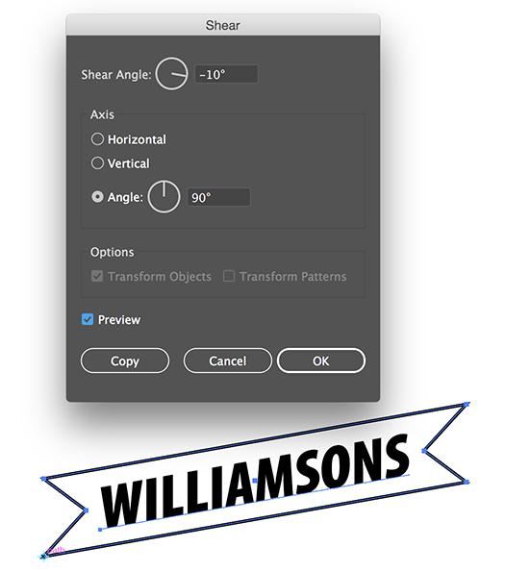
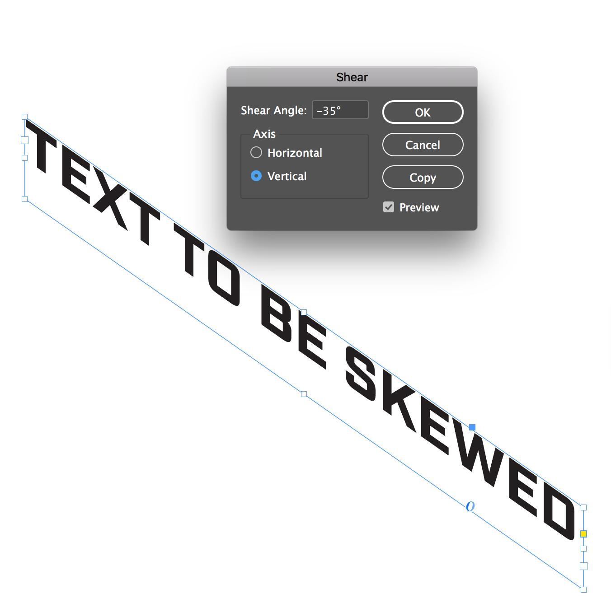
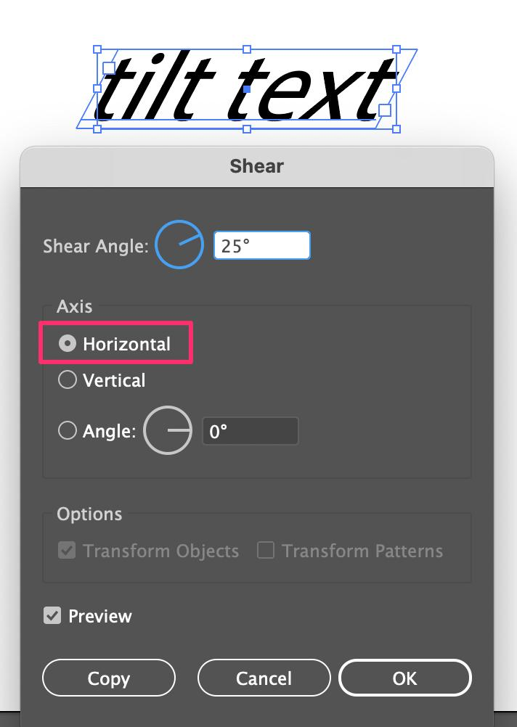
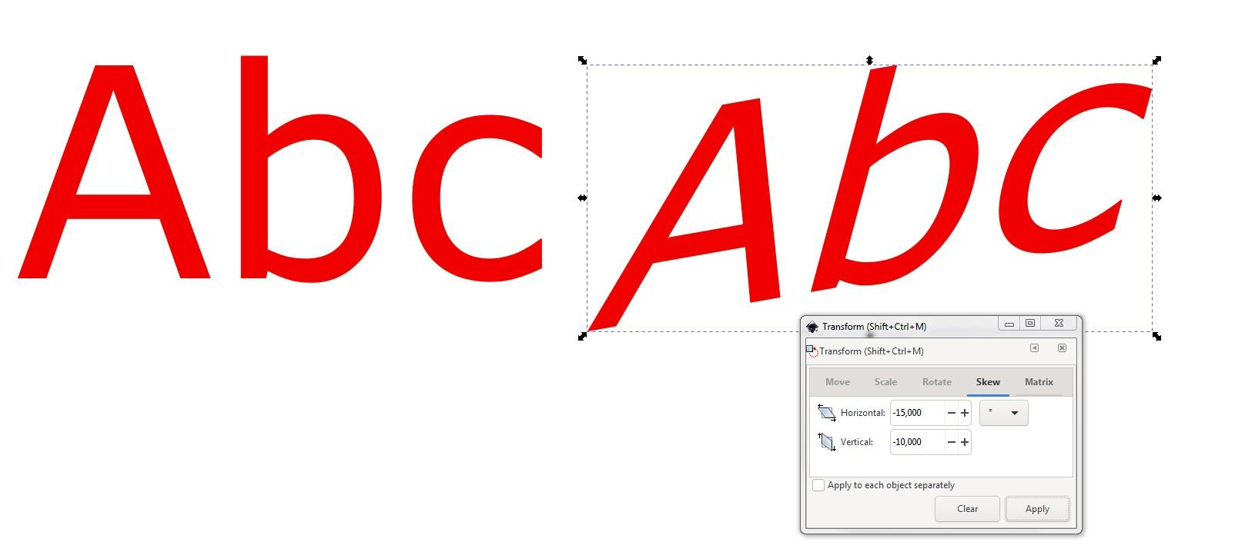
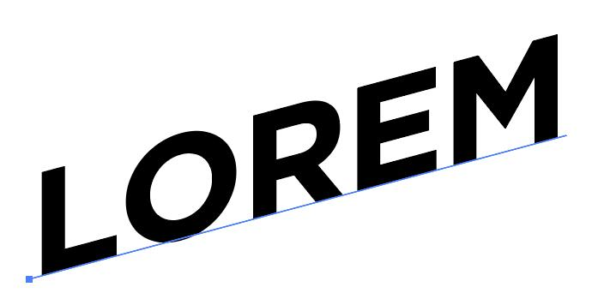

Shear in CAD
# Source: AI Source: Provided by: [Data Path: Persons Table -> ID Column: 1, Name_En Column: Motasem Essam] -> From: [ChatGPT] on [7/25/2026]
CAD systems use shear-like transformations to modify geometric objects and create controlled distortions.
Applications include:
- Mechanical design.
- Architectural drawings.
- Shape modification.
- 2D drafting.
- Geometric modeling.

Shear in Engineering
# Source: AI Source: Provided by: [Data Path: Persons Table -> ID Column: 1, Name_En Column: Motasem Essam] -> From: [ChatGPT] on [7/25/2026]
Shear transformations can be useful for representing certain types of deformation and displacement.
For example, when layers of a material shift relative to one another, the resulting geometry can resemble a shear deformation.
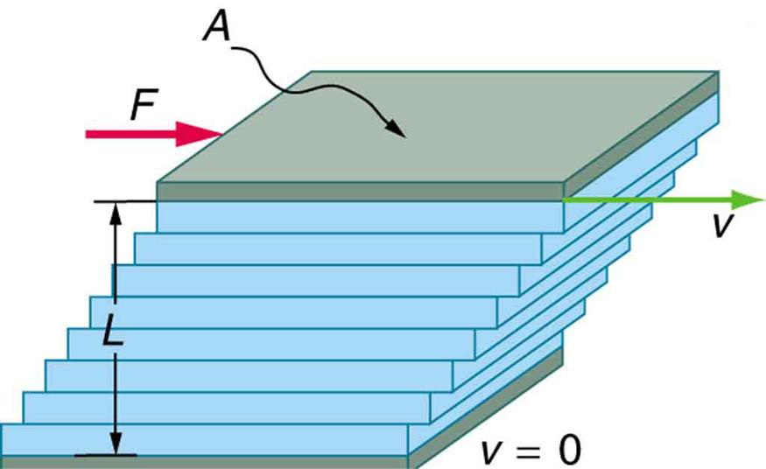
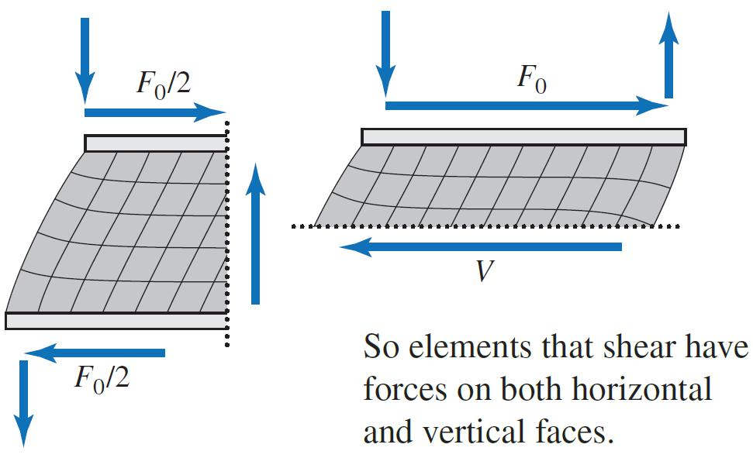
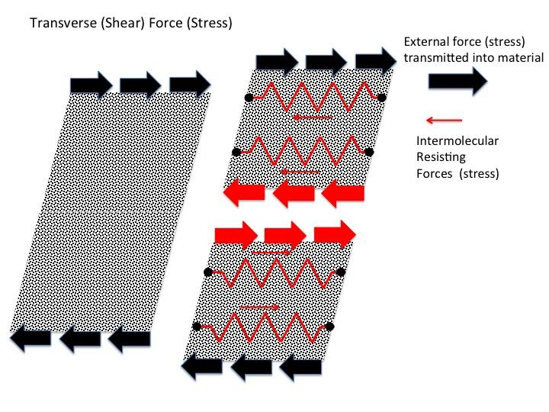
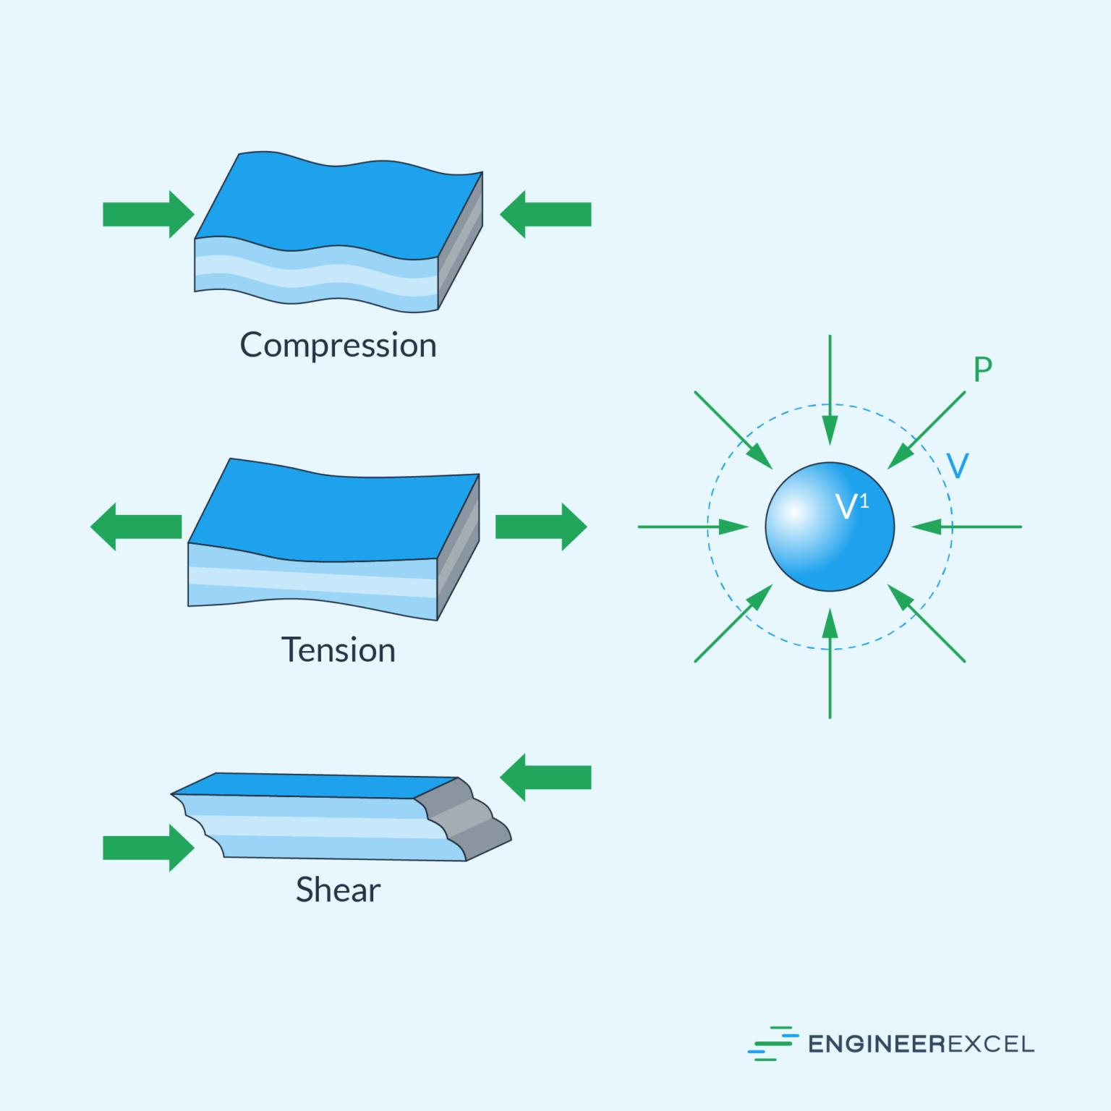
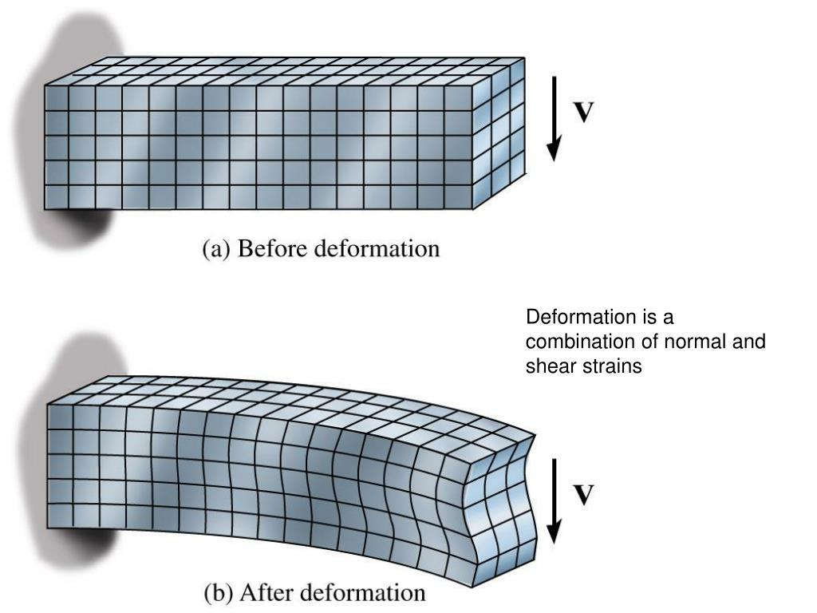

Real-World Examples
# Source: AI Source: Provided by: [Data Path: Persons Table -> ID Column: 1, Name_En Column: Motasem Essam] -> From: [ChatGPT] on [7/25/2026]
Shear-like effects can be seen in:
- Slanted text.
- Skewed images.
- Slanted architectural shapes.
- Deformed rectangular structures.
- Graphic design.
- Computer animation.
- Engineering deformation models.
- CAD modeling.

Advantages
# Source: AI Source: Provided by: [Data Path: Persons Table -> ID Column: 1, Name_En Column: Motasem Essam] -> From: [ChatGPT] on [7/25/2026]
Studying shear helps to:
- Understand non-rigid transformations.
- Analyze geometric deformation.
- Transform coordinate points.
- Create slanted shapes.
- Understand matrix transformations.
- Support computer graphics.
- Support CAD modeling.
- Study engineering deformation.
- Understand area-preserving transformations.

Limitations
# Source: AI Source: Provided by: [Data Path: Persons Table -> ID Column: 1, Name_En Column: Motasem Essam] -> From: [ChatGPT] on [7/25/2026]
Shear:
- Generally changes angles.
- Generally changes shape.
- Generally changes distances.
- Generally changes perimeter.
- Does not preserve congruence.
- Does not generally preserve similarity.
- Is not a rigid transformation.
- Standard shear preserves area, but arbitrary transformations need not.

Comparison with Geometric Transformations
# Source: AI Source: Provided by: [Data Path: Persons Table -> ID Column: 1, Name_En Column: Motasem Essam] -> From: [ChatGPT] on [7/25/2026]
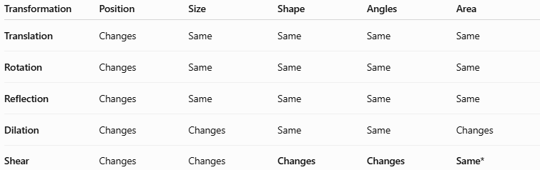
Transformation | Position | Size | Shape | Angles | Area
Translation | Changes | Same | Same | Same | Same
Rotation | Changes | Same | Same | Same | Same
Reflection | Changes | Same | Same | Same | Same
Dilation | Changes | Changes | Same | Same | Changes
Shear | Changes | Changes | Changes | Changes | Same*
(For standard horizontal or vertical shear.)
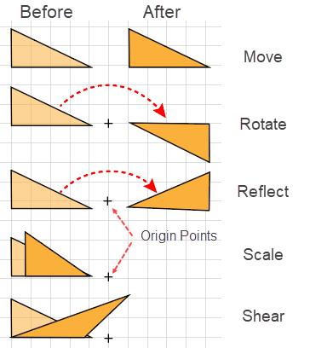
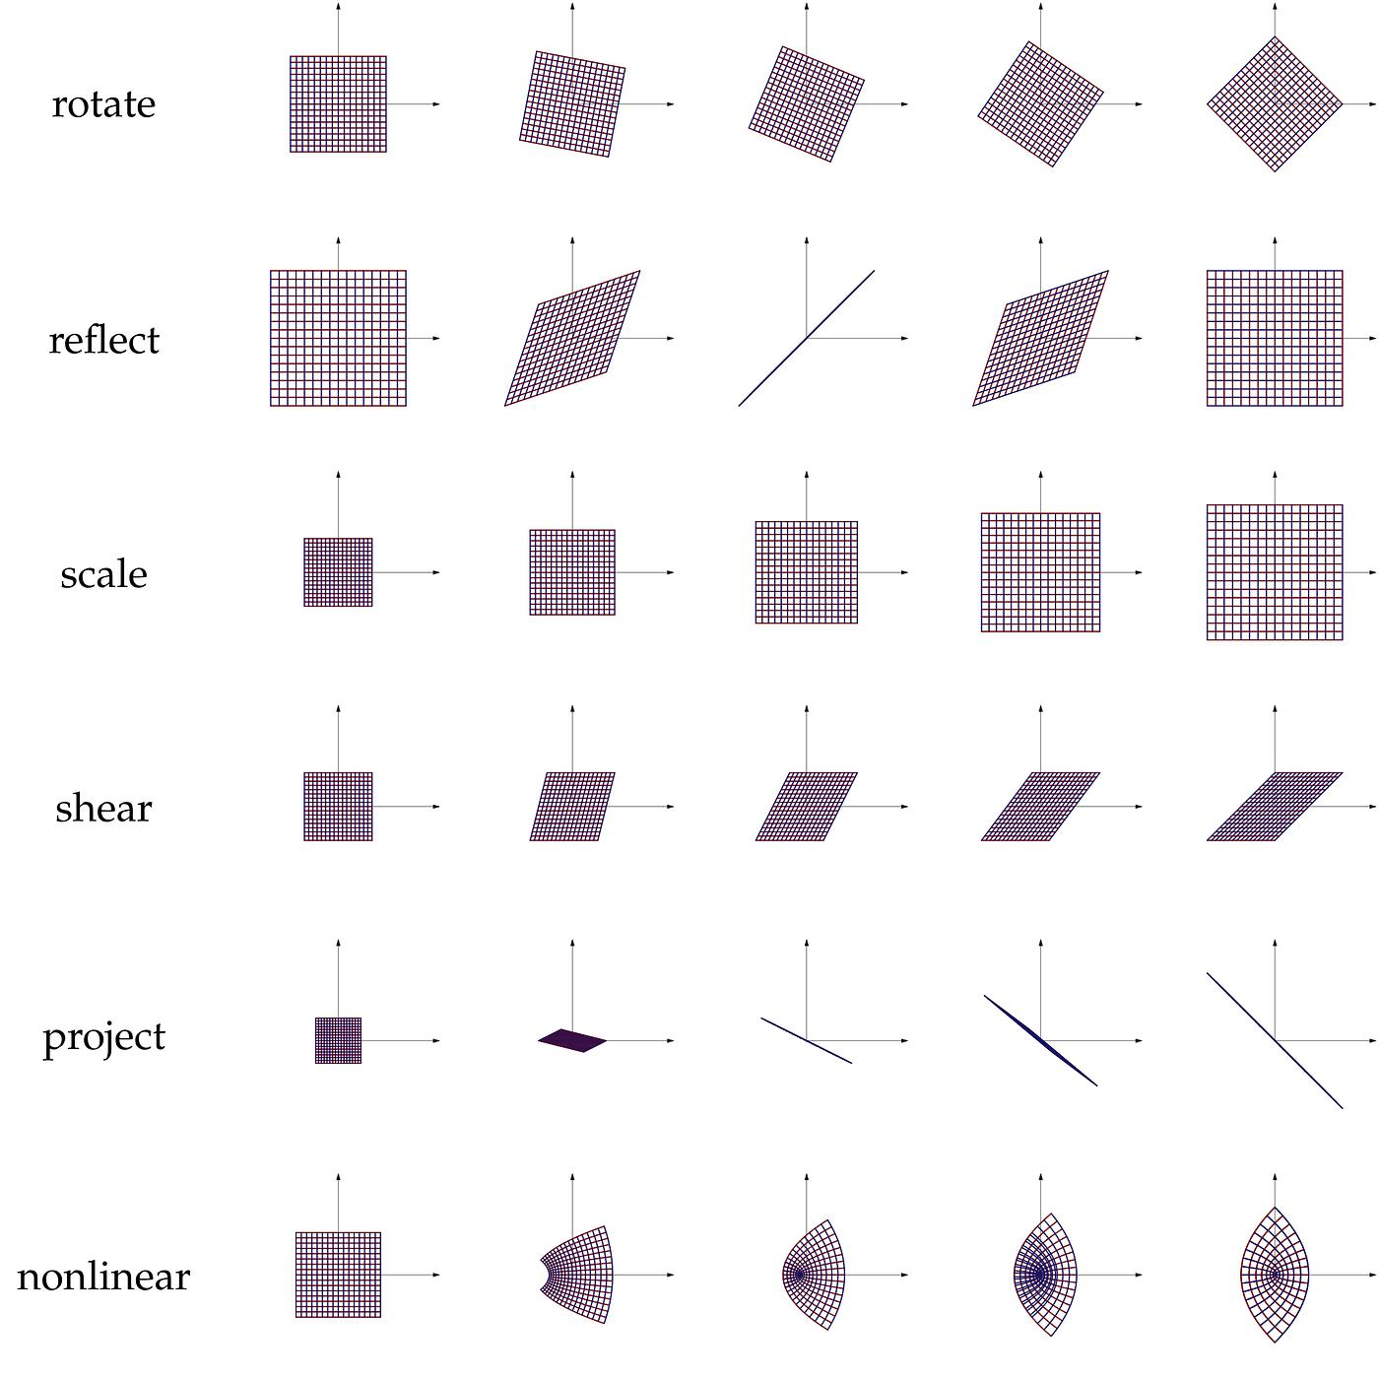
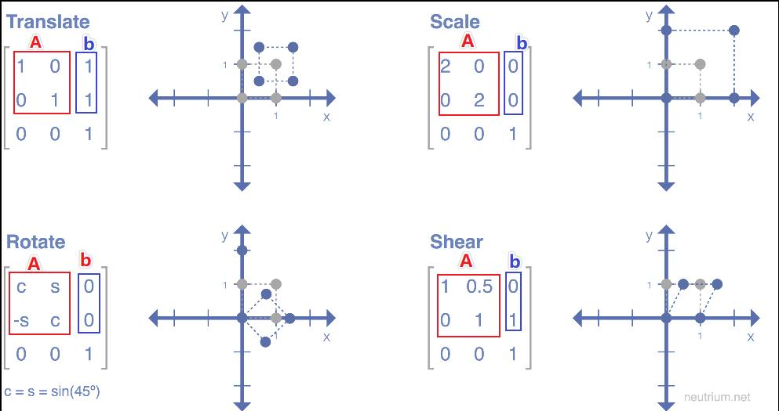
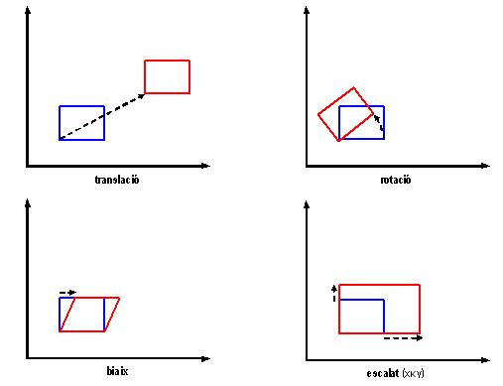
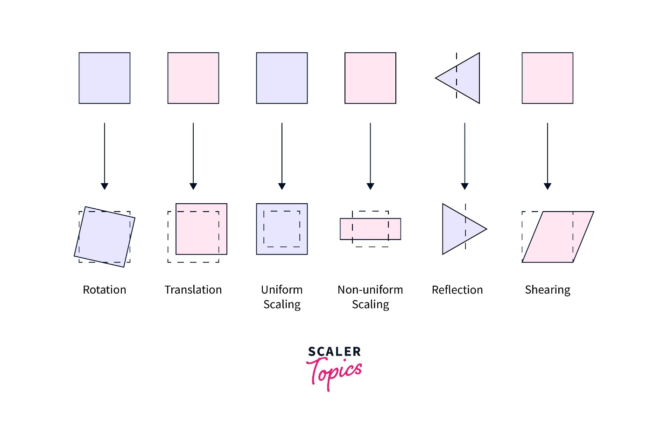

Important Coordinate Rules
# Source: AI Source: Provided by: [Data Path: Persons Table -> ID Column: 1, Name_En Column: Motasem Essam] -> From: [ChatGPT] on [7/25/2026]
Horizontal Shear
$$\boxed{\left(x, y\right)→\left(x +ky,y\right)}$$
Vertical Shear
$$\boxed{\left(x , y\right)→\left(x , y+kx\right)}$$
Horizontal Shear Matrix
$$\boxed{\left(\begin{matrix}1 & k \\ 0 & 1\end{matrix}\right)}$$
Vertical Shear Matrix
$$\boxed{\left(\begin{matrix}1 & 0 \\ k & 1\end{matrix}\right)}$$

Key Points
# Source: AI Source: Provided by: [Data Path: Persons Table -> ID Column: 1, Name_En Column: Motasem Essam] -> From: [ChatGPT] on [7/25/2026]
- Shear slants or skews a geometric figure.
- It is a non-rigid transformation.
- There are two fundamental types:
  - Horizontal shear
  - Vertical shear
- Horizontal shear:
$$\boxed{\left(x, y\right)→\left(x +ky,y\right)}$$
- Vertical shear:
$$\boxed{\left(x , y\right)→\left(x , y+kx\right)}$$
- Shear generally changes:
  - Shape
  - Angles
  - Distances
  - Perimeter
- Standard shear preserves:
  - Area
  - Collinearity
  - Parallelism
- A rectangle can become a parallelogram.
- Shear is generally neither a congruence transformation nor a similarity transformation.
- Shear is important in coordinate geometry, matrices, computer graphics, CAD, and engineering.

Conclusion
# Source: AI Source: Provided by: [Data Path: Persons Table -> ID Column: 1, Name_En Column: Motasem Essam] -> From: [ChatGPT] on [7/25/2026]
Shear is a geometric transformation that slants or skews a figure by moving its points in a coordinated direction according to their position. The amount of displacement is controlled by a shear factor.
The two fundamental coordinate forms are:
$$\boxed{\left(x, y\right)→\left(x +ky,y\right)}$$
for horizontal shear, and:
$$\boxed{\left(x , y\right)→\left(x , y+kx\right)}$$
for vertical shear.
Unlike rigid transformations such as translation, rotation, and reflection, shear generally changes the shape, angles, distances, and perimeter of a figure. However, standard shear preserves area, collinearity, and parallelism.
Shear is an important transformation in plane geometry, coordinate geometry, linear algebra, computer graphics, CAD, engineering, architecture, and geometric modeling, where it is used to create controlled slanting, skewing, and deformation of geometric objects.

